**Mini Project for Hospital Database Management System**

**Abstract:** Hospital is an essential part of our everyday life and it generates a lot of records every minute, every day. It is necessary to keep track of its day-to-day activities and records of its patients, doctors, staff etc. . Currently, most researchers and quality promotion professionals abstract patient level data manually from patients’ medical records and reenter the data into databases(Pranil Dukare,2013). This process is labor-intensive, which limits the population size evaluated, and is error-prone[1][2][3]. This project uses sqlite3 to create a relational database management system for automation the hospital management. The advantages of this system is obvious. It’s easy to access, edit, maintain and backup the detailed information for different users even they have little technical background. But this system has limitations insecurity and scalability.

This paper has the following 9 sections. Section 1 is a simple introduction about the advantages of building a database management system for hospital. In section 2 and 3, It’s the planning for the database’s components. ER diagram is presented and explained in details in section 4. Implementation of the ER diagram to a schema can be found in section 5. I created a database with SQLite3 and tried some use cases in section 6 and 7. Conclusion and preference are in section 8 and 9 respectively.

**1.Introduction**

(1)Why do we need to build a database management system for hospital?[4][5]

A DBMS provides automated methods to create, store and retrieve data. It may take some time to set up these methods, but once in place, a DBMS can make tedious manual tasks a thing of the past.

A DBMS reduces data redundancy and inconsistency.Have you have different versions of the same file on your computer hard drive? The same things happens in organizations.A well-designed DBMS will eliminate redundancy.

A DBMS allows for concurrent access by multiple users,each with their own specific role. Some wants to see the data, some contributes to adding new data, while others design and manage the database. These all happen at the same time.

A DBMS increases the security and reliability.Data administrators are responsible for creating backups for databases,controlling access and make sure it works the way it intended.

A DBMS offers fast and accurate transactional and management reports that give an instant feel of how the business is doing.

#### A DBMS helps the hospital Achieve good quality ratings from both the insurance companies and patients.

**2. Database Type and Data Types**

There are different types of database management systems. Mine is relational database system. It is a type of DBMS with a row-based table structure that connects related data elements and includes functions that maintain the security, accuracy, integrity and consistency of the data. I included integer, float, varchar, time, data as my data types.**[6]**

**3.Data Requirements:**

I have seven entities: staff,doctor,nurse,receptionist,accountant,patient and bill.Each of the entity has its own attributes. There are 1 to 1, 1 to many, many to many three types of Cardinality Relationship between tables. More details can be found in ER diagram and schema.[7]

**4. ER Diagram**

The ER diagram shows the various relationships among entities. It is used to conduct data modeling activities. The red rectangles are for entities, green diamonds stand for relationship and the blue ovals are attributes of the entities.

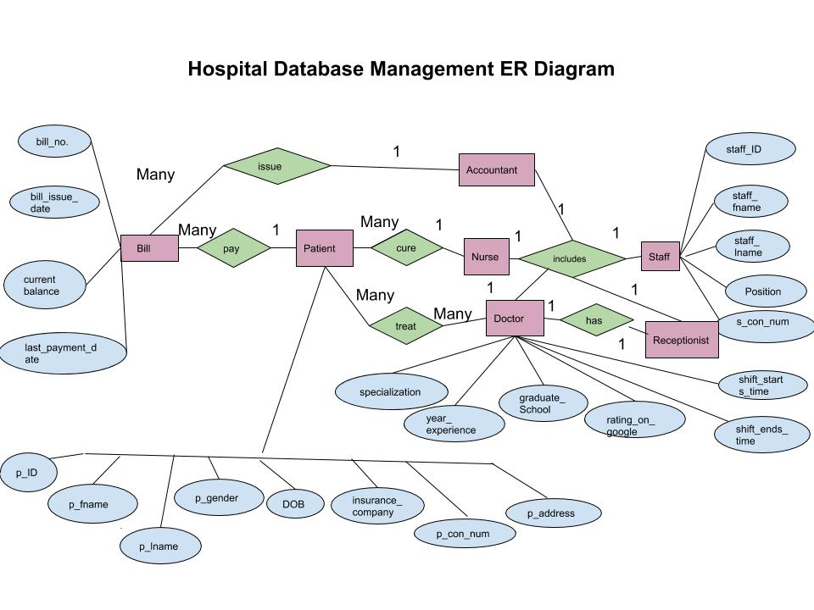

**5. A Database Schema**

A database schema is the skeleton structure that represents the logical view of the entire database. It defines how the data is organized and how the relations among them are associated. It formulates all the constraints that are to be applied on the data. It defines its entities and the relationship among them. It contains a descriptive detail of the database, which can be depicted by means of schema diagrams. This schema file called hospital_schema.sql can be found in a separate file with details.

**6.Creating Database Using SQLite3**

**Create database, load all the tables and data**

$ sqlite3 hospital.db

sqlite> .read hospital_schema.sql

sqlite> .read hospital_load_csv_data.sql

sqlite> .import patient.csv

Usage: .import FILE TABLE

sqlite> .import patient.csv

Usage: .import FILE TABLE

sqlite> .import staff.csv

Usage: .import FILE TABLE

sqlite> .import doctor.csv

Usage: .import FILE TABLE

sqlite> .import nurse.csv

Usage: .import FILE TABLE

sqlite> .import receptionist.csv

Usage: .import FILE TABLE

sqlite> .import accountant.csv

Usage: .import FILE TABLE

sqlite> .import bill.csv

Usage: .import FILE TABLE

sqlite> .import patient_symtom.csv

Usage: .import FILE TABLE

sqlite> .tables

accountant nurse patient_symtom

bill patient receptionist

doctor patient_symptom staff

**7. Use case**

(1) show every doctor’s information

sqlite> select * from doctor;

3|General surgery|10|Harvard University|4.8|8:00|12:00

6|Nutrition and dietetics|8|New Mexico State University|4.9|14:00|18:00

9|Accident and emergency (A&E)|6|Hopkin Medical|4.8|8:00|17:00

11|Geriatric Specialist|9|Cornell University|5.0|8:00|17:00

13|Gastroenterology|1|Mississippi Medical School|5.0|13:00|17:00

14|Cardiology|5|St. George's University|4.5|9:00|13:00

15|Maternity|8|American University Of Antigua‎|4.7|8:00|17:00

(2)Find the doctors who have greater than 4.7 rate**(join function)**

sqlite> select staff_fname,staff_lname,p_con_num

...> from staff s

...> join doctor d

...> on s.pk=d.fk_staff

...> where d.rating_on_google>4.7;

sqlite> select staff_fname,staff_lname,p_con_num

...> from staff s, doctor d

...> on s.pk=d.fk_staff

...> where d.rating_on_google>4.7;

Robert|Baxter|1-763-132-4526

Michelle|Cedric|1-140-261-7680

Brenda|Scott|1-544-122-7635

Fleur|Owen|1-352-793-4449

Christian|Avram|1-233-141-0890 (go back to file to check )

(3)Get the information of patients who have not pay off all the bills(first name,last name, current balance)

sqlite> select p_fname,p_lname,current_balance

...> from patient p,bill b

...> on p.pk=b.fk_patient

...> where b.current_balance>0.0;

Finn|Rhona|$3182.00

Ifeoma|Buckminster|$320.00

Ifeoma|Buckminster|$1000.00

Angelica|Stephen|$1738.08

Yeo|Chancellor|$1440.18

Scarlett|Uriah|$200.00

Scarlett|Uriah|$3000.00 (go back to file to check)

**8. Conclusion:**

This system has its limitations. For example, it offers convenience for us but it’s not secure enough. And also, the scalability is very limited, which means only one user can access the database at one time.For future work, we can works on creating a more advanced user interfaces like different users having different levels’ access to the database system. PostgreSQL is a more advanced database management system which can overcome two of my management system’s limitations.

**9.Reference:**

[1] .Thacker S, Stroup D. Future directions for comprehensive public

health surveillance and health information systems in the United

States. Am J Epidemiol. 1994;140:383–97.

[2].Overhage J, Suico J, McDonald C. Electronic laboratory reporting:barriers, solutions and findings. J Public Health Manag Pract. 2001;7:60–6.

[3]. Gordis L. Epidemiology (ed 2). Philadelphia, PA: Saunders, 2000.

[4].various-objectives-of-database-management-system

http://whatisdbms.com/various-objectives-of-database-management-system/

[5].https://www.knowarth.com/benefits-of-implementing-a-hospital-management-system

[5].<https://www.slideshare.net/pranild/hospital-management-system-slidshare?qid=4c6b1b5a-f1be-4d81-8b12-e0829b6146bb&v=&b=&from_search=2>

[6].<https://www.slideshare.net/iffi910/hospital-management-systemdatabase?qid=abce758a-9cdb-40d4-952f-da118ded7a64&v=&b=&from_search=1>

[7].<https://www.slideshare.net/RohithRohith3/a-mini-project-on-designing-a-database-for-library-management-system-using-mysql?qid=5cc0d283-f05e-4155-a83e-4d51e03c7236&v=&b=&from_search=1>

[8].Generate data for the csv files

<https://www.generatedata.com/>

<https://mockaroo.com/>

[9].<https://study.com/academy/lesson/what-is-a-database-management-system-purpose-and-function.html>

[11].<https://searchdatamanagement.techtarget.com/definition/RDBMS-relational-database-management-system>